Build scripts in bamboo

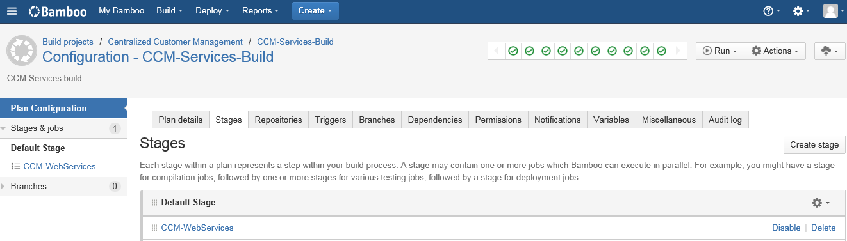
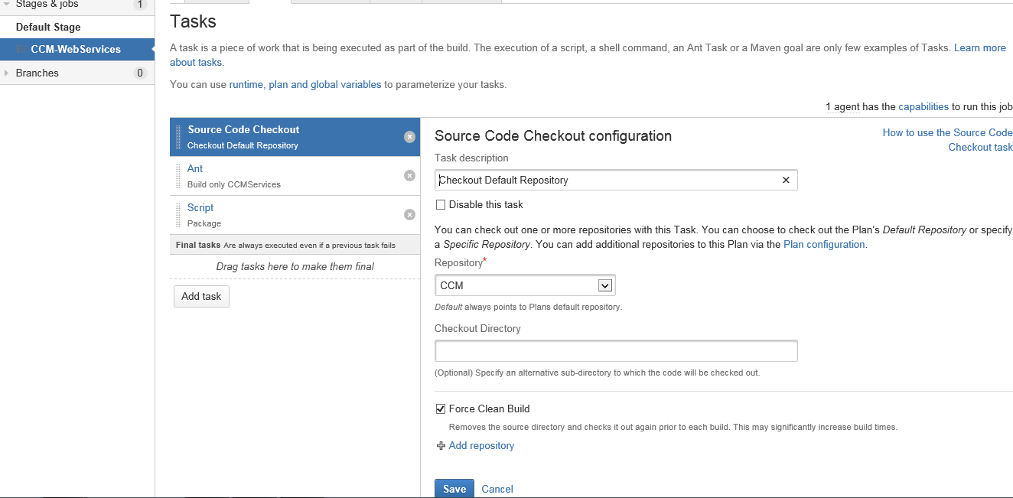
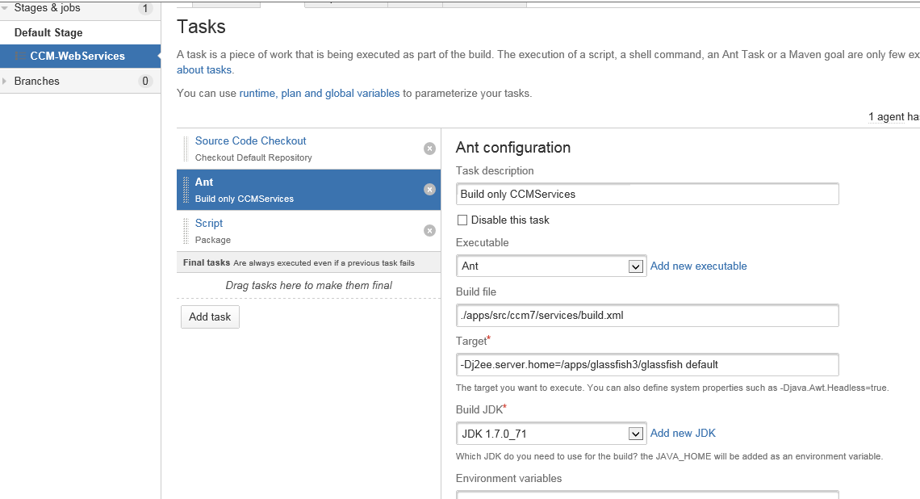
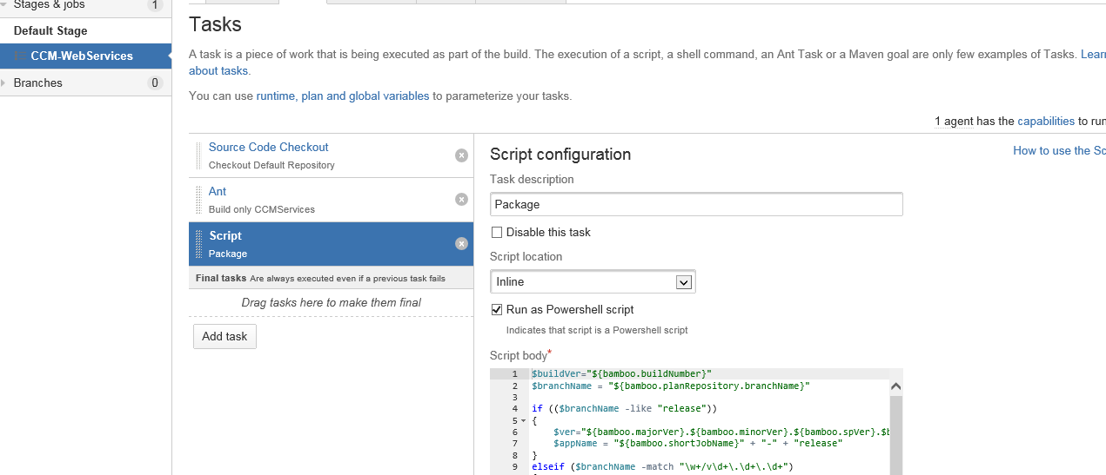

Powershell script for building the application like below :
$buildVer="${bamboo.buildNumber}"
$branchName = "${bamboo.planRepository.branchName}"

if (($branchName -like "release"))
{
$ver="${bamboo.majorVer}.${bamboo.minorVer}.${bamboo.spVer}.$buildVer"
$appName = "${bamboo.shortJobName}" + "-" + "release"
}
elseif ($branchName -match "\w+/v\d+\.\d+\.\d+")
{
$version=$branchName.split("/")
$tmp="$($version[1])"
$version=$tmp.Trim("v", " ")
$branch="rb1-" + "$version"
$appName = "ccm" + "-" + "$branch"
$ver="$version" + "." + $buildVer

}
else
{
$version=$branchName.split("-")
$branch="$($version[1])" + "-" + "$($version[2])"
$appName = "${bamboo.shortJobName}" + "-" + "$branchName"
$ver="$($version[2])" + "." + "$buildVer"
}
$directory = "${bamboo.build.working.directory}"

Write-Host "This build version: $ver"

$warFileLocation="$directory\apps\src\ccm7\services\dist\services.war"

if (Test-Path "$warFileLocation")
{
Write-Host "Packaging the app executable files: $appName.$buildVer.zip"
& "D:\Tools\7zip\7za.exe" a "$directory\$appName.$buildVer.zip" "$warFileLocation"
}

// Creating an artifact for the application developed
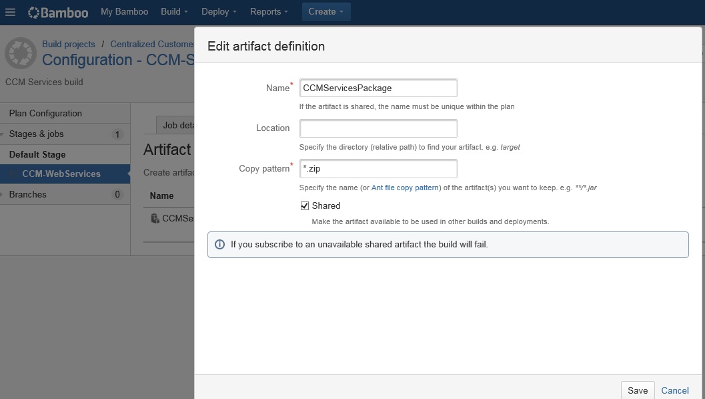

Linked to the repository we have like below :

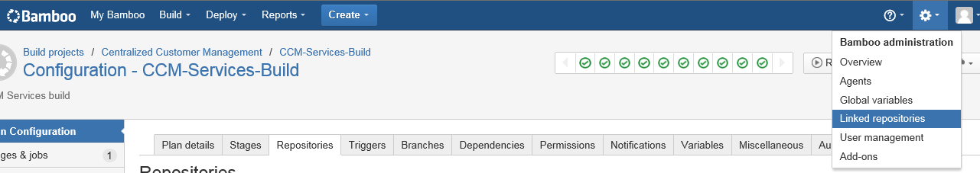

Linked repository and then you have to click Add repository
Select our repository from SVN or from Stash , in our scenorai we are selecting from Stash like below
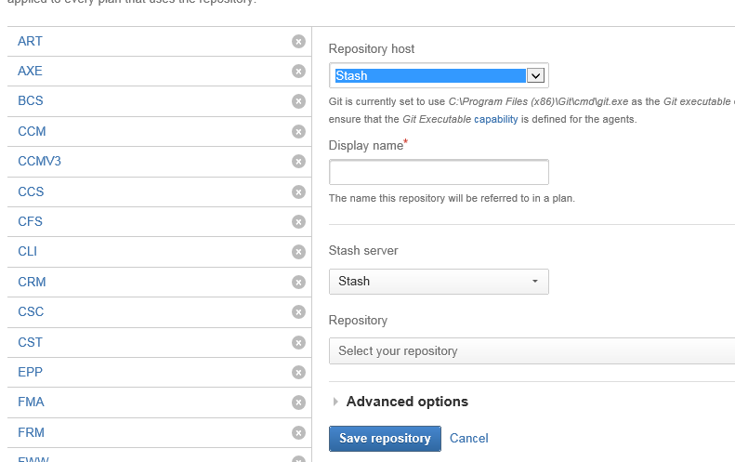

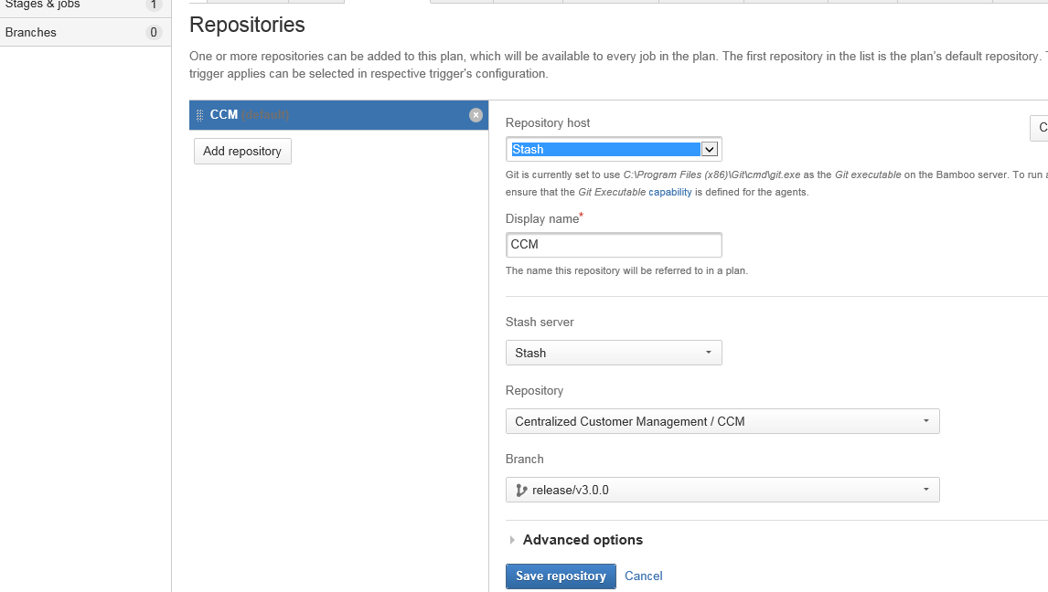

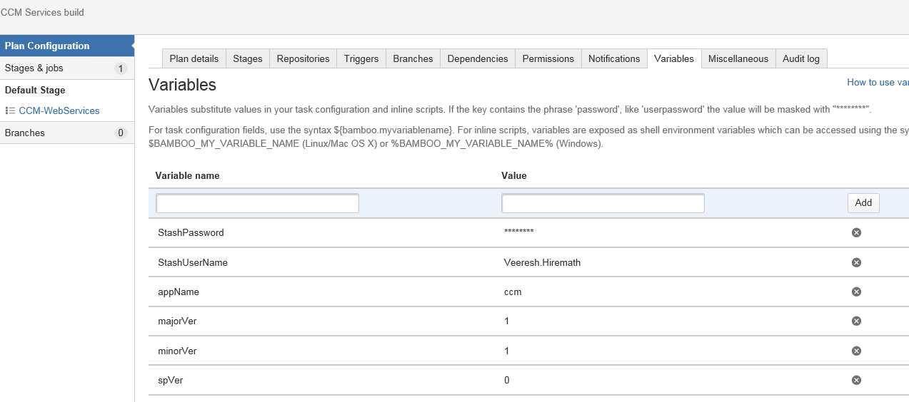

Once above configuration done we can start run the project, it will build and create a ear file and copy it in the build server.
We can remove and edit plan with the bamboo administarator.

Then we need to start with the deployment steps like below

So once we created deployment project for our build plan created we will see screen like below

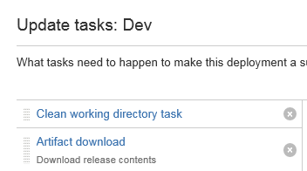

Then we need to crate SSH and SCP task like below
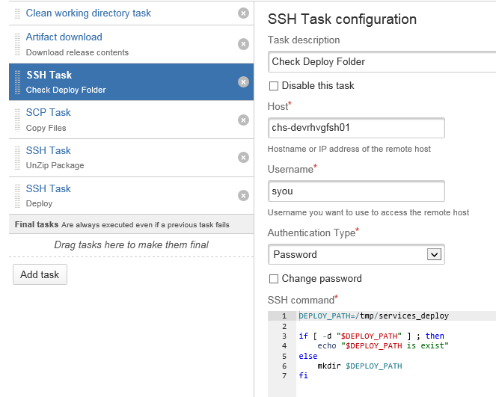
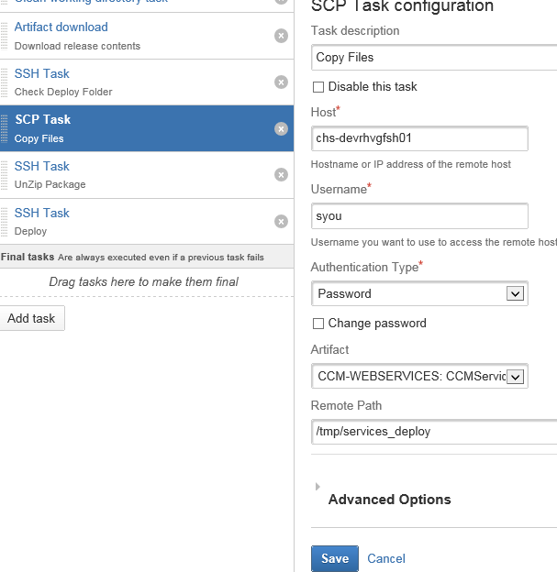
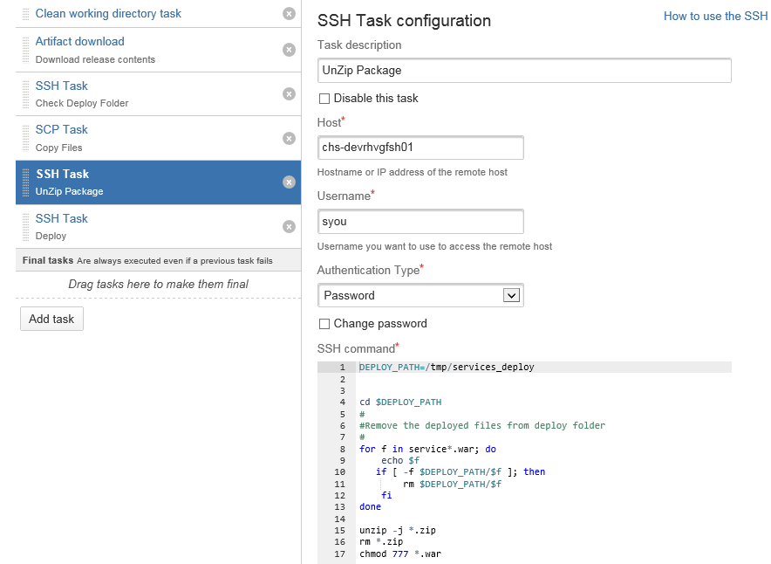

We used sudo comand to deploy our ear in the deployment server(app server)
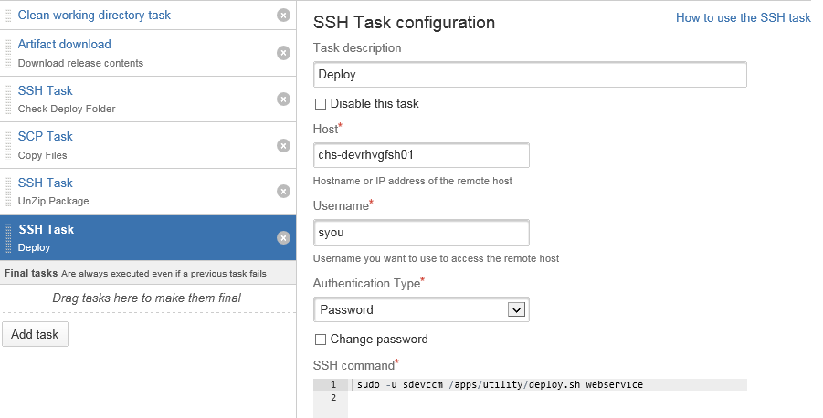

Or else we can use script like below in the SSH Task for deploy steps
GFHOME=/apps/glassfish3/deploy
DEPLOY_PATH=/tmp/liferay_deploy

cd $DEPLOY_PATH

for f in concentra*.war; do
echo $f
cp $DEPLOY_PATH/$f $GFHOME
chmod 777 $GFHOME/$f
done

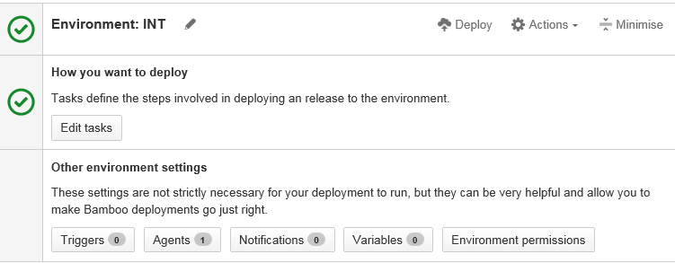

In the Agent button we need to select our deployment server, from there only we are getting our ear file.
At last we need to clikc the deploy button to start deployment process, same time we can delete the deployment project also with edit project option.

